DNS over HTTPS
DNS over HTTPS (DoH) is a protocol for performing remote Domain Name System (DNS) resolution via the HTTPS protocol.
A goal of the method is to increase user privacy and security by preventing eavesdropping and manipulation of DNS data by man-in-the-middle attacks by using the HTTPS protocol to encrypt the data between the DoH client and the DoH-based DNS resolver.

An alternative to DoH is the DNS over TLS (DoT) protocol, a similar standard for encrypting DNS queries, differing only in the methods used for encryption and delivery.
DoH is a proposed standard, published as RFC 8484 (October 2018) by the IETF.

Step 1: What happens when you type a website?
Suppose you type: www.amazon.com
Your browser cannot understand "amazon.com". It needs an IP address.
So it asks: What is the IP address of amazon.com?
This is called a DNS query.

Traditional DNS
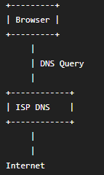
The ISP's DNS server knows
- Your IP address
- Every website you visit
- When you visited
- How often
Everything is visible.

Step 2: DNS over HTTPS (DoH)
Now people wanted privacy. So DNS queries were encrypted using HTTPS.
Browser Encrypted HTTPS Cloudflare DNS
Now someone on your Wi-Fi cannot read your DNS queries.

But who can ?
Cloudflare (Resolver) . Cloudflare decrypts the request.
So Cloudflare sees : Client IP amazon.com
Meaning : Cloudflare knows both Who are you? and What website are you visiting?
That is the biggest privacy problem.

Step 3: ODoH
Researchers said : "What if we separate these?"
Instead of : Client Resolver
they inserted another machine.
Client Proxy Resolver

What does the Proxy know?
Client IP Encrypted DNS Query
The proxy cannot decrypt it. It only knows
IP = 192.168....
Encrypted Data = ?????

What does Resolver know?
Resolver receives
Encrypted Data Decrypt amazon.com
But : Who sent it?
Unknown. The proxy removed the client identity.
Resolver sees : amazon.com , User = Unknown
Excellent. Identity and query are separated.

Step 4: Is everything solved?
No. Imagine Cloudflare is the only resolver.
Millions of users use Cloudflare
Cloudflare now sees :
- amazon.com
- google.com
- bank.com
- facebook.com
- gmail.com
- youtube.com
Not from one user, but from millions. It becomes One Giant Database. Even if Cloudflare cannot identify everyone, it still becomes a huge point of trust.
This is called : Trust Concentration

Another problem : Suppose Cloudflare fails.
Client Cloudflare Internet
Cloudflare crashes. Everything stops. Single Point of Failure.

Another problem : Suppose Cloudflare becomes malicious.
Instead of returning : amazon.com 54.x.x.x
it returns : amazon.com Attacker Server
Now users visit fake websites. Encrypted DNS did not stop this.

Another problem : Suppose someone watches your network.
They cannot read DNS. But they observe
- Packet
- Packet
- Packet
- Packet
The timing and size can reveal patterns.
For example : Every time you open YouTube
- Small packet
- Large packet
- Medium packet
The pattern repeats. Researchers have shown websites can sometimes be inferred from such encrypted traffic. This is called traffic analysis.

Idea :
Instead of : One Resolver
you use :
- Resolver A
- Resolver B
- Resolver C
- Resolver D

Imagine your browsing today
- Bank
- YouTube
- GitHub
- Hospital

Current ODoH
Everything Resolver A
Resolver A knows
- Bank
- Hospital
- GitHub
Almost your entire browsing profile.

Your system
Bank
↓
Resolver A

----------------

GitHub
↓
Resolver B

----------------

YouTube
↓
Resolver C

----------------

Hospital
↓
Resolver D

Now
Resolver A knows only : Bank
Resolver B knows only : GitHub
Resolver C knows only: YouTube
Resolver D knows only : Hospital
Nobody knows everything.

But how do we choose ?
This is where your research contribution begins.
Imagine every resolver has information like this:
Resolver | Trust | Speed | Distance | Load
A | High | Fast | Near | Low
B | Medium | Fast | Near | High
C | Very High | Medium | Far | Low
D | Low | Fast | Near | Low
The scheduler calculates. Which resolver should answer this query?

Query sensitivity : Not every website needs the same privacy.
Suppose you visit
youtube.com
Privacy requirement
Low.

Now
bank.com
Privacy requirement
Very High.

Hospital
apollohospital.com
Very High.

Government
uidai.gov.in
High.

Streaming
netflix.com
Low.

Step 11: Trust score
Every resolver gets a score.
Example
Trust Score =
Privacy + Reliability+ Availability + Integrity + Low Failure Rate + Good Reputation - Attack Reports - Fake Responses - High Packet Loss
Imagine :
Resolver | Trust Score
A | 95
B | 88
C | 72
D | 41

Step 12: Rotation
Instead of
Always :
Proxy 1 Resolver A
your system changes paths.
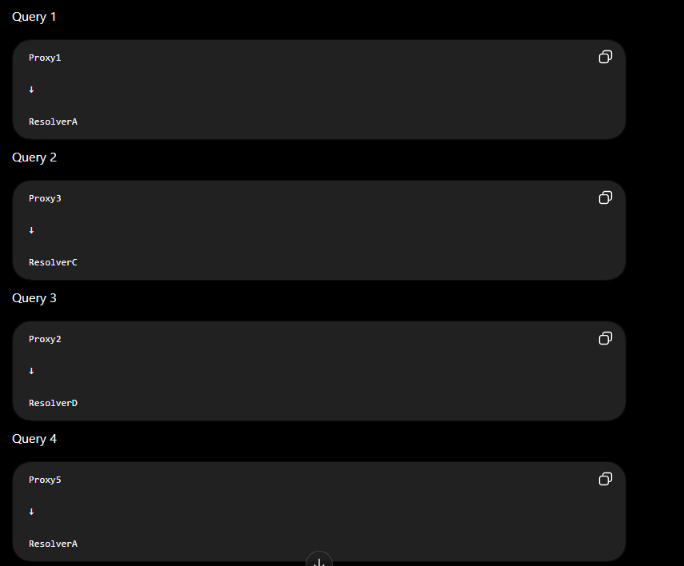
An attacker now has a much harder time correlating traffic over time because the observable path keeps changing.

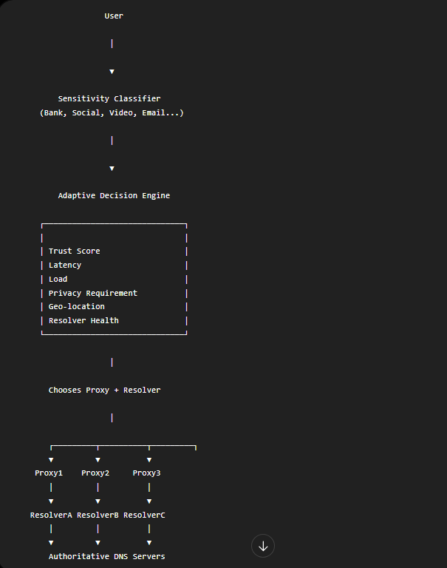
If your scheduler simply picks the resolver with the highest trust score every time, then eventually all traffic goes to that one resolver, and you've recreated the same centralization problem that you're trying to solve.
Let's see why.
Suppose you have four resolvers
Resolver | Trust Score
A | 95
B | 90
C | 82
D | 75
If your algorithm is: Choose the resolver with the highest trust score.

So what should the scheduler do ?
The scheduler should optimize multiple objectives, not just trust.
For example:
Decision = f(
Trust,
Privacy,
Latency,
Load,
Resolver Diversity,
Query Sensitivity
)
Instead of asking: "Which resolver is the most trusted?"
it asks: "Which resolver gives the best overall result while keeping trust distributed?"
Diversity Penalty : Suppose Resolver A has handled the last 20 queries. Its effective score decreases temporarily.
For example: Effective Score = Trust Score − Diversity Penalty
Example:
Resolver | Trust | Penalty | Effective Score
A | 95 | 20 | 75
B | 90 | 0 | 90
C | 85 | 0 | 85
The next query goes to Resolver B. As different resolvers are used, penalties change dynamically, naturally spreading traffic.

